Olist Dataset Query Results
- Total Orders.

- Unique Customers.

- Total Revenue.
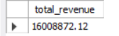
- Average Order Value.

- Monthly Revenue.
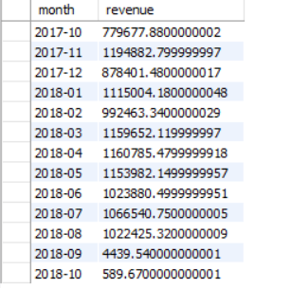
- Orders per Month.
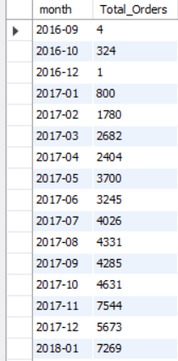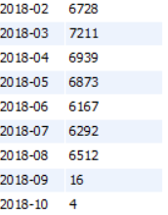
- Top Categories by Revenue.
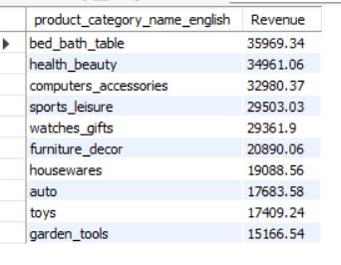
- Customers per State
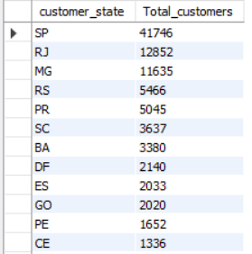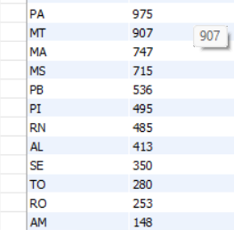
- Repeat Customers.
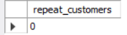
- Avg Orders per Customer.

- Average Delivery Days
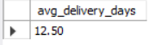
- Late Delivery Percentage.
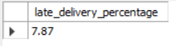
- Delivery Time per State
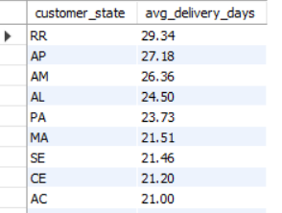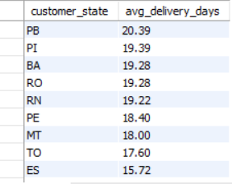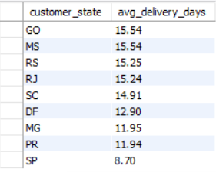
- Average Review Score.

- Review Distribution
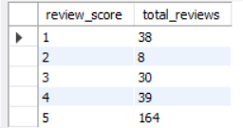
- Late Delivery vs Rating
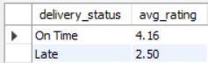
- Payment Type Usage.
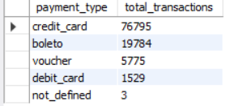
- Revenue by Payment Type.
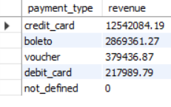
- Avg Installments.

- Top Sellers by Revenue
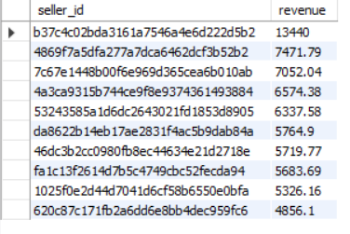
- Sellers with Most Orders.
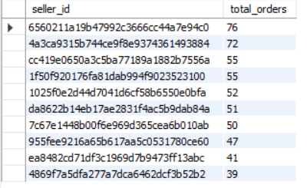
- Most Sold Products.
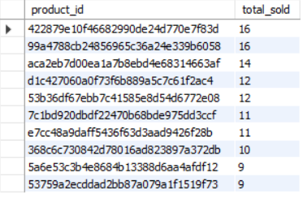
- Avg Price per Category.
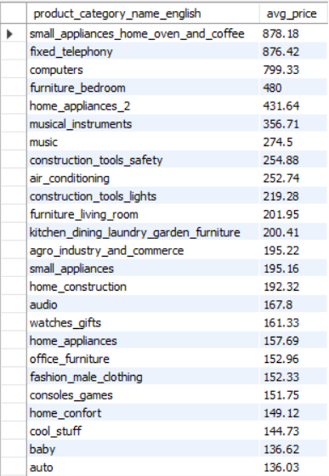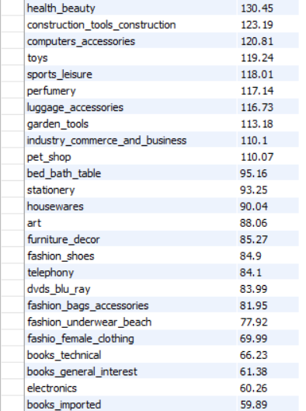
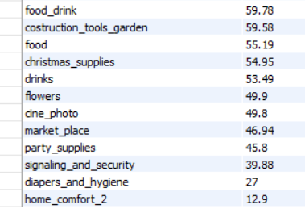
- Top 3 Products per Category.
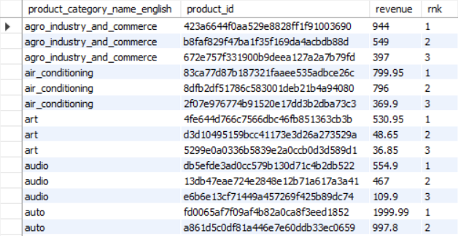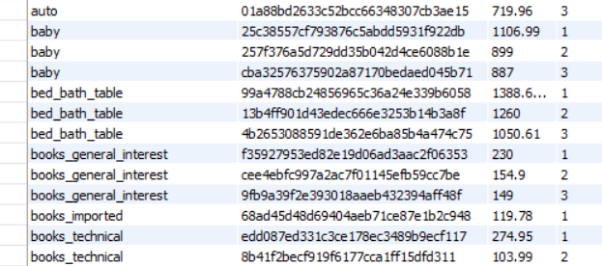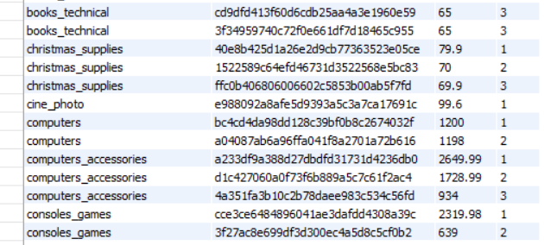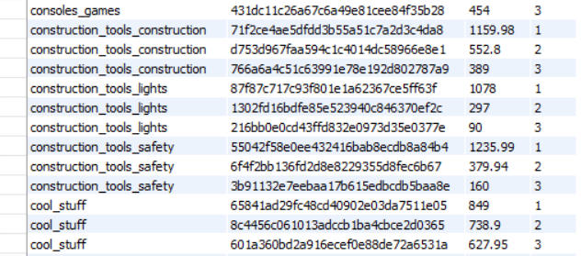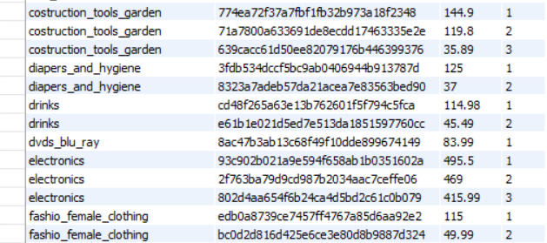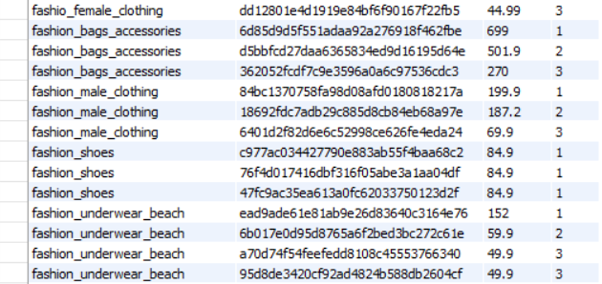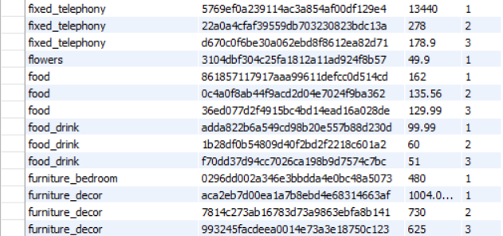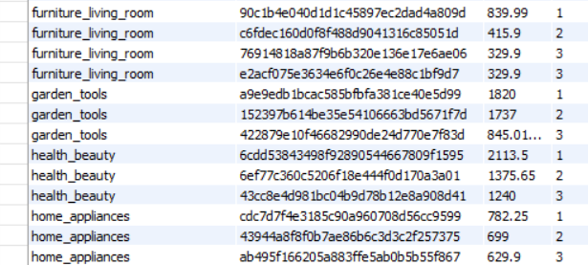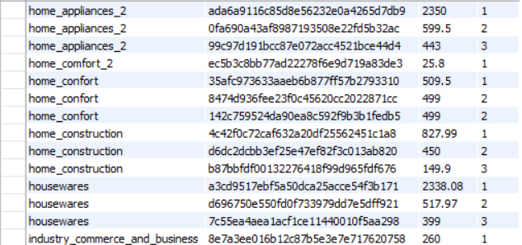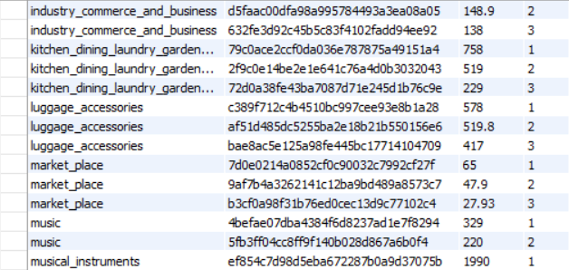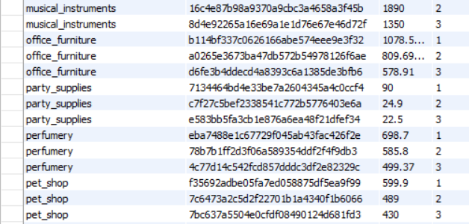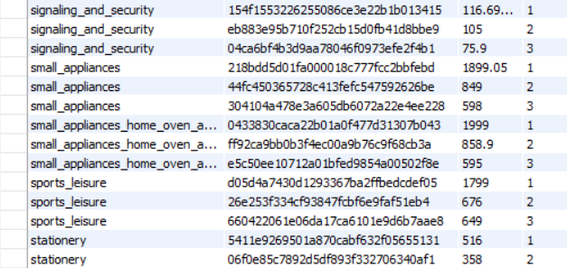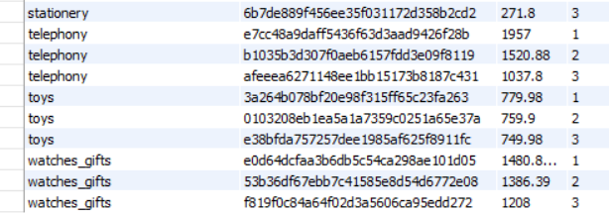
- Customers Above Average Spend.
customer_id | total_spent
7e2ca73af071679902a9ba14d7c3cee8 | 340.08
625784c6aad212dc7d249ea10e276617 | 154.14
425ce6f29109ed3511a62cd0f92d7170 | 354.64
38f1fb4bd44289ca591479b76905cdbf | 262.94
becd44b937217776c659d9465b22808d | 415.93
7974eb74e94d3f3e1031f74d1b97ea5e | 172.29
2c5491a76ec0a56db58282ea7ae70617 | 159.07
d31dbd02ac052d662285f678f8994326 | 161.47
e6f5b234bb0d847f10eebd70130c5d49 | 219.4
fa3a8736d5ae8f7df9b0a4154d0b14dc | 211.94
d2000bb65d12d7c93b7e27e6c961757d | 162.65
a94259e3111386ff1ae6f1c3712fe6fb | 372.72
855f0b8c477c57d9c5d0210c260459a5 | 155.73
aae50600d30bf2efe013ca4c1754ded7 | 167.82
4150cf7549e3776c9c3c6b54349b23f3 | 251.63
43831164a0be75b0bd8fd92cc8c6b232 | 179.22
2698695709c21e561e5aedcd0f297a69 | 303.76
db2bae68f396fde5433217c9730d1b7e | 320.07
0980d72e94bede8b0f7d8a4cd32511c8 | 297.95
c0cc17e4ee16598f33ce7ccc36e3b4d0 | 183.65
8f437c018d57b705d06574998fc4f348 | 921.04
115eb2fbfc2d8446a2a6d38a0d800c6a | 261.16
b2b863015dad63b56e3b9dae12d52f71 | 379.67
dc0617ac29c280d79e4e2930274342ed | 275.11
be64f74b2773efd8d765f8417b65d276 | 172.42
8bceb21c15bad608c6606d297ee46d8c | 649.86
aa5dfb0872b3828aa250acb54d387266 | 229.63
f15f5e1d8a0248d9b6552b4d39122bdd | 218.11
7508680e17b526665363d2bd205b44a3 | 313.99
5c819da02aa0a65eca9a8086a00a9885 | 209.94
68de9ab6df869e6c10cac725487ff831 | 209.67
2f0d2cbd1ac4d6d80d7cbc6bc5f22160 | 225.96
a4a00c41b5e3ed88bf0e0bb96576c2b2 | 176.78
028d9c8cb891f2860106890cbc40834f | 212.94
0f13ff76e67fcf442e4f706f353bdc7e | 405.33
c47f0ed7fbd21fc9be2cfca83f0dd490 | 565.58
69d8d9775287ba592a957eba2211d351 | 198.12
de1e5517fb50896bbdcff5814fb31802 | 262.37
7c397262827fc3b4fb1eaee0d480cbbe | 172.55
eab62436056c6ce3853a17dd6892951a | 164.32
a791256150a6975326b329cad239f6f7 | 512.9
87b5d2464401b73336fefb8b1e3b91c7 | 224.94
4244b230226a6cc815ffa70c4394b06f | 436.42
1e12754604af85397680cb28482f73a6 | 1828.41
3e337c99e0f5ff7ba9a4b98fbf7412fd | 158.97
d0836b848a9c6d8fe285a19b028df814 | 185.84
796e0c6b3690401bd5592b7ce89be9f2 | 180.32
a3462eb52c92ce66a03f2eb65b58de6b | 179.04
1224a9f43655b57c469ab096e6ba5dc2 | 241.74
97f0b42943a89b0d5af2e2924481a1b4 | 263.61
7a34180d4442d594be87d3e69bbf0ba0 | 175.87
ede6d420b95b2d4145c3e0de07483597 | 854.89
d4cd9729eeca5306a2c039fe6e55601e | 273.27
4b83fd2609057103e8d7604ab567c5e6 | 708.95
6233e1c1b76b3f0e1527afdd8db0c7a1 | 320.31
998f126b3cb8b108a8b7784019afa475 | 172.14
a02dfdaaf5b634d7684b11d1c9626d1d | 193.84
80e6d004e23e1fa0a1048f7297b458e4 | 160.4
7b7f18d5f94e3c25bd66ec35e87383f0 | 2024.31
dbb305170569978cff51fd1047ebb11b | 199.52
957f8e082185574de25992dc659ebbc0 | 299.84
b4211f38ade936b62d702e56ec4068da | 176.16
5dda11942d4f77bee3a46d71e442aec4 | 824.76
7353b0fb8e8d9675e3a704c60ca44ebe | 615.53
e75cd2b8044ef17f9fb52badd80a76d2 | 209.15
c40c7807639289e3f1308ac6e5bc104f | 165.57
54f60df7bf8415b9714bd26eec037b2c | 154.9
82b03a0031f872239665983241c52179 | 249.62
94e4969b72d31602e59dbb8d2c7c1d09 | 178.72
ef6ea25f1bdbd8acf3ffa440a32634c6 | 309.22
a8dae326e70d36bde8a49e2207f1f0d8 | 285.54
502bb2b647bf2cd2b55e73381cb9699c | 161.37
60134a69479bd4d54c03fd5076bbe984 | 200.23
1b848bc58de81ae1b800cf3a4571bedf | 446.51
877b18b6aaa2faadfbf88c43a9bd5c42 | 164.66
3271f9dc34c1d718be03cff03dec7acd | 190.48
9dc4634838a5ef569c6f8869c55f6dcc | 170.17
d62fe8fd4137b91ddd653cccd56811b1 | 188.94
71277afecb5c7487d4c7f39f6697b7a8 | 173.68
2d143929faefe132157fe22c40f72978 | 168.93
cc89bb0f40fb83134cddad77849dd82d | 905.03
9f1595b82c93e652dd8ffd5cc4051362 | 159.1
13fd7ce9f08449dec2533119379a2527 | 393.46
41ce2a54c0b03bf3443c3d931a367089 | 179.12
9a80c8377644236e27f59e83862f1ae2 | 312.91
9146a82ef0aef149115d9365555b4343 | 203.3
284e326e8a71e55bdb0b210ddfabaa27 | 1480.73
4a293f5fca6868a2c0d69e89494dafb7 | 155.98
ff9602a062f03021213c2ffcfd7f7e9d | 213.78
4afc1dcca5fe8926fc97d60a4497f8ab | 392.6
6531d4ad5d401bc0d4fcca146cff73b1 | 340.47
c2d9ace6123e42fa913bd6fad131bf09 | 165.71
81e08b08e5ed4472008030d70327c71f | 346.09
c5fb3c3494f2aa02774d5930a1f981e6 | 309.12
1589f4bea320a405a122738de980c6e2 | 156.55
08999a20d9741d9513c368676f5531c1 | 210.56
9a4900710ff76d73cb3a0d152e73adf0 | 554.4
6641d4bc99bd20a09ec8c66f4c7ae0e3 | 195.17
5c49d0bcb0f397a3a5dec5512755f848 | 222.68
191984a8ba4cbb2145acb4fe35b69664 | 191.46
7203eb38fea2b4a15dd6c39575314aa4 | 320.18
e27702751ec7fac85bfdddd986cc03ce | 189.08
ccd8e3459ad58ae538c9d2cf35532ba4 | 174.72
cee874c9e449571c0663ade1be67d070 | 249.31
7d527c98f408420a9d5c953e5b89215e | 222.68
ba682ab005cd6617c7d3384aabf4a45b | 235.27
86ff82570097f39b2193254f540e4a69 | 161.3
bf173716098c076e4e00285843e37e5d | 270.57
faf620ef3ae77d18586f3d921d677e18 | 217.06
e76048064c31c156e15c4a07c48a3b1c | 416.55
55e6b290205c84ddd23ddf5eb134efd4 | 209.41
4a2d2e5f1e7d78c701d998b92fe72bd7 | 163.5
aa76c84a162fed7b8e5b935ce4ea7533 | 386.65
46ec8bcd9649f0f7bbb179bb59d6702e | 442.52
fcad74a7e0dff27c33e36cbd78280bf9 | 265.96
d1c40bfb050a09047a4c4426fe9a2893 | 228.43
6ba47b28c84367f0c27769d78f1c3adb | 278.06
230ab395e91b2421bd00ea45b60b23cb | 238.41
638c6674418fc58283a73c078bcb076f | 360.4
cb633030180d869d7bb76aa783a78b6d | 220.04
764fb80689629a0092fa11ada23a0c4e | 1008.3
76ba803a22ca2f0892036acaead6a065 | 265.84
456dc10730fbdba34615447ea195d643 | 313.19
d954782ec6c0e911292c8a80757ef28d | 176.61
1690401c1e48c9526a79e72ba8c069a2 | 216.26
eb19d6117ee958ab1e3e3a2d8b230083 | 198.56
95200d2b14a993f488affb398652a2a2 | 197.46
31ad1d1b63eb9962463f764d4e6e0c9d | 169.76
6520161e793f944073a132d97e9af083 | 154.58
996595f66cb179af29159ee6c539dc10 | 183.85
a2aeb9a5650ba6f97ebd3335cb0dd610 | 173.28
2dda54e25d0984e12705c84d4030e6e0 | 333.91
7a33b68891edd3370f13fc2adbb312ac | 161.79
2fa6eb7ad02d5495e29bebb6d4774257 | 160.3
7acf55df0298e1d2c31200fb4f6fb93b | 233.87
a3586509a27757e4e4825418e8f1174d | 169.87
49c6a9bd8786031fa02ef67014dd2bc1 | 178.51
384a027682b0ddc9d88f4aab723d9730 | 195.17
bbce8db51b94aed05e4da1ed311bbbfc | 182.2
83da8aec5d2e8b2847e6ca45bea5588f | 436.7
c4184e264c25f060e2022b22c098ab18 | 1291.39
e5e50b9e762526a12499a7bb4e97a862 | 213.14
e7fb8d2c8a581e31b93defd84ee988fe | 163.52
d854800a320bbb07b484f76894e4638f | 2031.09
6da199107f9bca1b26fe1fdac3937f6a | 392.56
ddaff536587109b89777e0353215e150 | 154.19
ffdc2af7160aed3bad21cbc8ec68c0c5 | 180.45
a9f353609242c268174ec433f45f8440 | 246.64
26495cdb066f046945177209f10b67fb | 502.12
42ec6e7b9d6b378c51d60ee3d0d65b30 | 234.17
caecab08cac2be52d89f87462765b4f4 | 216.93
1d877053716a2f3be7e0c13096eb75f1 | 163.25
dd854e24b40e3bc2b306946dee252015 | 253.4
df2af8efbfb8b719e19e7e08d0017759 | 1570.79
f2e25f6f5b6b91207fae80a1c29d1a2d | 176.16
8df60f4b5c7991242bdbde7c034f2057 | 183.29
1fabee44ed07815c74f684fe4826c686 | 172.81
c9e9578f912e420d05abfdadb830cda5 | 217.45
42bb82a17b70bebcc6090d38d894ea3f | 306.16
93ada7a24817edda9f4ab998fa823d16 | 409.79
ea23ab6bcf9413b8841a1a69b9af0686 | 312.59
a6d8c2fa92836346256c28d885d9eea0 | 186.76
8c0e35584a0e33e799e4c9113a8d80cc | 219.19
33a366be73843c5da3d68f3d3427afd6 | 722.05
595a590ba9c0127d59855c4dba71a69e | 171.01
ac4e328e156057d602bb4d7b146d5468 | 326.36
e6c386cfd321a1708aa60ff6b8f46449 | 1692.05
6ca7c0e971c24ce0931f148588ef23ce | 187.87
1910935b7377a45bca463c844d7a071e | 221.28
88ca1a52550c2c65c9b75121cc26b060 | 162.5
dd9fdfd1c2d9c13f398bf35eb1f18325 | 202.79
dbbb8e776de0b4704d10f043c30dbaa9 | 351.73
2ec09b0312464955bea7d384332ba8bc | 993.55
94af59d9cac1ae1976312584f628ef6f | 209.11
107d449d8a73c9dfd9673df8ea684348 | 246.42
dc75c9ef71e6cbda48cbe416729b79ba | 313.53
468c4f2750adc583cfca2f7223d7ebff | 244.15
e5af401ed4e2cd001e38f5e998845560 | 369.92
2c069e58cbc8b600e8e4078598ee2c35 | 163.24
c1055f5a8a55684492575d082da04127 | 164.63
2b4c285c63cde3581cb7d06b70db65c4 | 317.53
ef95061d7fabce59a19b991b10e9bfc5 | 408.15
4a2231202fbd4dfb5678c0241d7cf141 | 242.8
02f0bc4b5ee293031637b7e8d75a5484 | 321.51
9aed6fa0db5da18a5433bbff4ef320b8 | 213.56
8dd1c4e88c1db62830ab1f7c56b6ee42 | 227.38
a06d5e88e559441070e2c1e9d4be49b0 | 235.7
745797df7e1f604c7d608c43b43f62e7 | 199.51
c5bbfe67cb7212c9e6390fcd598caf85 | 257.99
4a727b3912355023c5284abd4b1c6956 | 239.42
0c7a95280b3f80eadd81c829e093dbec | 297.2
45706797a925907d4ba536fb8c1e909a | 271.08
da757be0eb9978feb09365ed3bdfc679 | 197.87
b1757da2a461d581e1a3b280ca181b7c | 205.26
45c9fcdb0cd88a5630cb4405c4d2e4a7 | 338
b78af1eb8561b53cb6b93162ecb34e49 | 157.41
4338285648648cd4a82f4498801ea736 | 313.78
5cf1b1745fff59660522b4ff7b475374 | 241.22
a629686911e06a8876b4b570375c1710 | 537.16
a4f6fc82eefc6a54376eea73b27df682 | 171.32
7e31ff5a549f128e99d5cf90f3b9a649 | 204.24
59168d27c5da6a50e3d1f03d482e80b2 | 161.37
49f6c48a95ac4eecf06c6a01b586e14e | 171.44
2c8be64d4c648b0bbf8412c53761ae27 | 757.68
fea04944f4e1fe567fc5151c02529203 | 625.4
ce0ceb45fe0c526c8b6959f36131687f | 300.74
0489975a325480c9e385e9f135bb13c3 | 170.43
0f0603d577f299ca129f39109268c546 | 157.99
a83a89abd16a03e6376fb659ca7b6612 | 201.47
fb31ae52945c45377e1ba9644b7f78e5 | 189.59
e413b51d04fdbe619c2cb28cda3046d6 | 314.21
485abc56a464a56ff6e9f9a752ff4308 | 217.78
7199038790946ae4e75b8efc080f9dd2 | 990.45
c9f6f241518c8603c0c46f0817ba487e | 157.21
42e6dab95c5c9ff9067a6d954ccdcfbe | 215.06
99f297c1c95e0dda633b7e584ec2a4f3 | 343.5
f9c5e7c93778d6fdb505bd69aae820b2 | 459.5
fb6f154449a5398e2ff6ad8d8c6df862 | 190.43
5f2cfa9c8c34ab5d785fbf253c63b930 | 220.03
02731f7e9105dec7fc7fa715ccd821b3 | 160.14
8ec5d1bb574d20d61a22a89127329060 | 305.57
2ba3edf091e33c433e095b2f53716362 | 246.36
dd24965dd5aa551df36ce4baf180445b | 177.59
2364ed5a865ac9d255eac0cac6366ea0 | 444.92
64f0489f9721747547375903b0468371 | 155.14
db76ebd0d51c2b3cc44d84cd6df46336 | 165.84
ce0518f0279ef8b73d94633720e70b9f | 324.32
f7fd634460c772aa7c67b397c3a0e831 | 160.45
264d02bf55980e2934f42a50c221e97c | 162.04
ba936b691c12f67e4c24f195f5d2f5bd | 180.75
1181d20ba074543832905275fd087e73 | 217.1
e0b36a2b88ead76489b6a2d913c997c3 | 386.76
e60e08d06effbf35575193d851fd8007 | 192.03
9f5a2f912f123d541a318029712fe90b | 301.19
738b086814c6fcc74b8cc583f8516ee3 | 1376.45
7a3bd3b37285f0ab25983420cbd01f4e | 473.12
494dded5b201313c64ed7f100595b95c | 259.06
61ce7eba15a872699599957e5d18f0e8 | 154.7
ddbd5d378c4a0981ba1ef29fb8e40b8f | 998.49
62383c983441809ec8977c644dd37a54 | 165.7
24bffa8e3281713f3aeb4eb619bf0002 | 230.1
c396c33a13de8470ca7f0fbff9ac4e9b | 417.55
c6227a9291e7e9a4fe69b48356d4b38d | 609.24
d1c715c3201e2a54b45c12a6ae5e0f67 | 177.49
e9185b3210712b4d59df466551941825 | 154.73
e7679548f90781fac8359cdbe2e2c729 | 305.63
838bc2ff67963202eb29e748923c15fa | 177.58
cdfe21141f5df77ba0fb20bef6621a9f | 322.17
acd575d7382968889f41a5a3f37510dd | 175.1
d3d7dd13a66c2d1362de5251fdbebef2 | 164.79
478778636c75019554439f75286a22e3 | 161.97
b7919647bde69acc948baa47823d6c75 | 218
220d30b547b088ca7b34fef7d7a54523 | 211.91
f8508e9ec506a046a25f3a4a63d0c630 | 200.45
26b37aea51f367cc0cfcf19c80944e58 | 219.2
b6e18008af6aeb4a5ce5574c15ca2b48 | 619.9
ab2ad178fdd3930c37f3e12ea2a3495c | 214.42
de4c2b462c44197b26b6e596865da44c | 606.46
7422267f46a52991b0a78f0e10e1ca65 | 168.14
5f4b2469ef500958180a1e9bd6edd1fc | 166.23
4ff41b1c00bade23c1ddcdabf5fe9009 | 415.51
7681fbcd3ede0e49dd00c993245ffb3d | 594.69
39f944145e00598d075faec0bb1f447a | 177.36
3ca18278aa462567e7bb52302cff31c4 | 237.08
2a22ba1cb2f182b16cfd4b7620ea6114 | 248.76
55f35e2e63c2446e9eeea957bbe164ed | 196.29
f19622365d4c40c686c8ca3bec559e48 | 222.7
00a6e2753fc2652cb87386ffbf5792b2 | 192.14
ba5a299fef88320dbdadd124f5333bc6 | 242.34
1ac1963cfcf8bda4b3b64300c5b11b16 | 193.84
9ccdd15c9060a6ea0d5f0abbb7324022 | 170.01
41dcb106f807e993532d446263290104 | 397.26
542a1542afb92ac617f667ed43640af8 | 262.75
ff20530ce012df37828978c25f3dacac | 415.83
a8b396cd7edcd4340e02a07685084cd6 | 217.78
df85b96ba2ce3e49bde101b1614f52ac | 171.32
b48ad91d707041578581aefae1f7c385 | 232.71
627b92adad5c3e29a2c4518bfcf13fec | 695.61
a2c0d0dea2025e9edfddd1952a437985 | 362.93
6968ea6ff6368619de4d031a15d5c9a6 | 217.78
3f083b9f62e687be8d84684c7d54c8db | 2751.24
3c628393675b42c6b5ef89461f68ecef | 389.82
cae5d18352d2eb7396bd594c706f3624 | 355.77
ed8c52327eecff596e141636d5b556d2 | 753.94
321e587bfd564d724fa0883998543eac | 278.43
c360961ef98b0d4b28357b7fd0387673 | 224.71
33b0d5c2438d9cd6426c6568dfbb908d | 257.94
27c4c0e841788a80932b2500f7c0fd36 | 184.69
36b9676e6379e30a0df0cd7eddb48c2c | 168.5
3203358dce6a6dd1a5d190113a70b68a | 162.3
8338cddb98bbda6167cbec66540a8942 | 356.64
503740e9ca751ccdda7ba28e9ab8f608 | 175.26
a37a37235d7b3be3e2f95747ca589bda | 162.04
272abefcdb7e7438a251e6c92f1d5873 | 166.29
d99d07b571f5e15e61469e5f77e3b027 | 544.92
2edc6f92f35d994f26752db0fd1f5727 | 389.07
a166da34890074091a942054b36e4265 | 187.57
f11a663853dc243e55733d1fb954a8e3 | 251.82
fb7df68b487c7340f5a4e9c5d4ae3e73 | 1166.43
6df6c2eeaad604627aa688ae063741b2 | 315.84
d9442164acf4b03109425633efaa0cfc | 916.02
2e21846cd2112929ca821e9716281192 | 235.83
cb85fd1337a9b227e49fbcb893babd71 | 307.68
69ee62ecc8d2937fca0e1a3d4de5a2ce | 269.97
c65121f92dcf3a7d5a7b612ea1756bdc | 329.55
b5dff22ad6f2531a66adde7810935f70 | 295.38
047d2000bf864a26eb2559021ec958e2 | 339.09
e98e177d7d60c154a7da57096c1680f4 | 215.55
215db0d9420c188518c58426fc946c9a | 320.45
3c9a7cf7435eb8c2afd717c62809b521 | 176.83
b727708ffce3a65ab875d65f42c59b0a | 896.28
735774ca9e99d1d85ae5f53b4958e6cc | 259.98
c9c7fe860d602373a9e93f8bfe9d877a | 286.09
61cc0e28471e6851f580dbdcb60854e3 | 231.99
a23bb087dccfe3c78336749a1818a423 | 230.75
574bc1bc07d89145ec04fd7a5eca5c3e | 183.93
7a5846ef7b6f7d58630bb4b0aafe2858 | 215.15
640246e27e1df1ffe19d062550d0d5ab | 173.59
f5afca14dfa9dc64251cf2b45c54c363 | 386.33
d19f254a07da73a055409256e9bfe40a | 314.34
6eae55140163e2af86907a15a478f2d2 | 188.31
1c5b37d20011c637ad1a5b6d423c7483 | 215.56
e200b9823371b1da02a7ac74702a1f3a | 164.79
ac7e3d34240c0ebfc003455c2e04d10a | 295
00f73459a4d3be97ff307dc869da0aa9 | 247.68
db5374a5a0de70b9b226cc07f00c7de3 | 163.97
fb8b8298c590af3ee3169596c5ec2114 | 235.84
61544bf6d5b15f5dcec75603b22fcda8 | 179.22
a4156bb8aff5d6722dc68f605d8fa241 | 206.87
8fc86d31af29c9a6ef80c6c950666adc | 228.79
d265ebaf9a745999a30e6a9eb778fe3f | 399.25
a5fb3b16bcb08fb9f1290f225390b829 | 225.72
527b26bd8ea58b018efd96060cac5ccb | 159.13
6b3d95268023f35b096811b8834a3d03 | 216.83
c6326604c234a96928cd7f255f358978 | 194.11
fce8eb224fb44bca516d50d140e88ca0 | 611.81
0e8ada3654b94e0d569b44233db3c9dc | 195.92
7bf43e2d079beb839eaff3937bb6fe81 | 257.77
cf8ffeddf027932e51e4eae73b384059 | 188.41
b53cc3c992caaa45ec73cfdde4d839b5 | 155
690834a6694434cfb474ee30305154f4 | 162.04
7021912eee1bca99920c934a3d8b27c5 | 365.6
6ee76c3941b644506c8dc73861add1d9 | 163.68
7cec2ad3ecf1b10ce543161225a13a97 | 1916.08
5e320e6a4f03e2e74bc22e1158237fbe | 305.7
2f9902d85fcd930227f711cf47012bdf | 301.3
05e996469a2bf9559c7122b87e156724 | 234.28
2098460678d4ec096748c21bea80fd87 | 480.33
7526d70ce84a55e4f85d4b39e91e2ac7 | 448.71
e5f6020aa61432f0dcb0fcda1c5113d9 | 159.04
2cdced5335b76d6e563bfa3a40bcf7a4 | 294.14
259d4795add79a2b1ea46f0210db8766 | 403.95
e29b173e2f8fdd7546b5d3cca8385032 | 286.59
873951dbadc164fa5d61eed16cf38770 | 173.13
2a1dfb647f32f4390e7b857c67458536 | 508.17
b70e717fe0599c3bf2f69725b26fdf8e | 166.35
078d86e7bf40b188f0e5ed6d866c21c4 | 285.59
7aed8da5ae4e0e34226c47f3bf041956 | 204.06
c77d0b043f408944f858efe328a82738 | 166.4
2df6fa407bea6af2e165b3dc8355d382 | 169.49
d177bd6051d525711221cfe59b43aa3b | 222.38
e4d57ae0cd29436ff661934056bca9f4 | 158.59
439f42a3cd2931ef5f1bb20e54f2357d | 399.72
f3875c080718c7e384875c4af4951afa | 181.76
c34beddc345e97b15bb556100207a176 | 450.99
d44661372e501386cce8554861971115 | 546.45
fe86c2c022a8d1665da64dabf0ceeaea | 232.35
d1c6e90ab127d42b75ef2e548b4461ac | 198.16
4d6793a25de1f63ca63869c6cd4b7b1f | 307.64
660c817af06c2d842014a12d5871c1f9 | 311.81
9ba926ad01e17e9a308791ae9cb69699 | 316.57
4e7656e34357b93f14b40c6400ca3f6e | 162.25
1b116df734af684a39602a867430a4ae | 255.92
b2de21eac1284b5492269771d68da739 | 171.3
e6c67be032549956a7f9f38854a918f7 | 412.16
b470bfde759425129d684b306fce715e | 196.37
152d5eeccb9cbfd05ed8ab2395a14b66 | 444.54
79b516ac255abbf7531ea1ea5b43d0db | 195.13
485d59ed46bda4a60ac9ab15c32ec63c | 227.6
3da647f1441ed4b18ac7a0ded0056570 | 163.69
0de81b04e35176808cda689cb88bd263 | 192.22
a00cedaaa02a3875ce936ecf15c567b9 | 438.48
aaaa6531d040b9cef69bf13af9be2fd6 | 264.07
6e340889d05dbbe467a8de3ac31ba55c | 188.34
f8c3d249c98f91b25409df45d4a095e3 | 207.02
abd052c275218899a215aa3dc9e1494a | 318.3
ed5b3952b9a674f798d9cd2fbd854ed5 | 210.54
dc20dd848e86e03be23cc9883378cd65 | 244.38
20ef87add57e8cc2760bec8fdff748fa | 487.79
524d1030b6d659f0aa5e03f459a89b34 | 338.77
790cbac97e71291719b52249d721519f | 189.37
1c9e4589fd7fa6552ce6e19f4e9f1746 | 210.92
ba0660bf3fffe505ee892e153a2fbd49 | 209.2
a455f91b7ce36ac2eee4d8c54a05946c | 333.6
84d818ae645c84264965bc603b1d173f | 186.1
d4af21206f409c5ba8408216b06b00b6 | 157.91
449057269c318304d8a753f64c181b07 | 163.32
4b64f923aa84a7f224260bc473819ad6 | 236.3
52fe8f0d46227cecc08e692dbe3c16fa | 185.03
6d7c040dec6d2f6da6a63929bdec436d | 2158.57
133cb7dc019947e49b9541c6c2795ac8 | 164.71
d420ffd55c04ab7659d5e02b1ea6e298 | 305.51
1a87b8517b7d31373b50396eb15cb445 | 865.01
2238c417bc745d8fa7d7389d8b22154b | 206.51
6928be51d9496f1aab5da8f15a21aba6 | 164.06
bb43ad860331b5cb19e33357a187b7b2 | 184.93
74df30b888082a6cfaeb6bbee623e6a2 | 328.82
38f63d5e41d4edd85614e2297502aec8 | 590.08
d0e6cb83a3fc27f56be011b2941f54c6 | 402.49
e4a32f8f3648818820a821cd577ccdba | 286.54
4f86e2b6bb393847cfaca4bf4b1b82f6 | 177.02
ac055528f5a69cba5e02d73ad1ee9a74 | 262.86
60582a6628af83a283474d8c94e3ff7a | 218.08
0d3740ed03979ba91a9cb4eb6300dd49 | 373.17
a06cdf060608a4a80705bf5860bc8f58 | 255.29
b806115ed21f16a50c4f3a28947aeadb | 544.18
84277fad7c65394532e950000400cb73 | 304.52
fc6408fa8083f3c01b1f287709714321 | 183.13
9deaacc2a9d6b105c1e27790708843b4 | 157.16
f4f2d12420b95f9239bcda119491f2d4 | 253.01
698e55af1f6f37f7f304a74eb93b85b0 | 161.84
972e7c5340efc85efad5a12e49eff86a | 186.1
1bb26cb73f617c0b4eed520cc297ea8d | 347.31
05f9f7e304de1bd029ce39f107848608 | 158.52
fac60d7c4df3896a5af5db6c91e03797 | 518.39
6668dac2eb65c90a4b5662e8d5a38514 | 335.48
6d491c9fe2f04f6e2af6ec033cd8907c | 240.23
f69cf4381400f65b36639b8e1c11092a | 1075.12
dd3926dff45a3459c4bdac0b58a2a0bf | 334.12
45c4444133e260eb729533fbf3b1837e | 180.6
ab308900612e0f192d73e0051653af5a | 170.18
ec1ca447b2357dc984f111bb42d901c9 | 1165.99
2800b82a7d904585f1f78639be21f877 | 417.02
b7aba705e32253c6d5159e0155ba4fac | 175.77
6b0135fff11f14781d72fc93315eec54 | 349.08
076dcea2eb6c8dbe9354f7c0d8670a00 | 210.64
9408366cfabe249cc4e4680dffb79c5c | 174.99
7b4205ad0699f380983dfbd2f26f67e0 | 175.56
5b6d2b7a038cd6a079db2ac2c0138daa | 239.39
422d5038574e8ef4a62100750a7bd05e | 221.79
6c9de7274450f72bc4fb8d28f629ef4b | 156.28
3971ac136496b4368c1431bb5bce0929 | 378.91
9aad6db5643769b3d802a87328ec31e2 | 163.69
06757bb75493151d0e73ce8e3bc32987 | 248.66
ee4a4b5842e03fbaff366b9459e08b95 | 161.01
a7822dc752d3f4130c061c077d15d5e4 | 238.81
8e2e23cac1496c337274b16fb7d57886 | 383.98
9583b047c90d4aa1c5c68b4065ba7f4e | 232.72
93f0c8eaf1b7a1c951d234d56b232e35 | 169.3
e8fff6456a357707eba84dae9ef01dd5 | 157.75
a4c79e8a9d9fcb82de5dddf33918fb47 | 205.57
986c590aed8ad278ffc220f81b2d8e4f | 217.78
943a02b9d5564146f21343b020bcb5de | 398.14
9f6618c17568ac301465fe7ad056c674 | 231.12
ed034127e0801850ca9162dd9de7a106 | 283.54
f1def85ade6e5b754d5f84a958fd48c2 | 186.45
f57351f8f87213bbb758f2f902f600c2 | 165.64
80f5dbd6c402fa67462768a508de4168 | 399.44
0f5cbabecf09e4453086b1db91138cb8 | 919.38
29d768c153dabfc1ecfeb0c1c389727f | 159.94
3c2317ef8102b203b9857304ca808858 | 169.48
457aa02da26931909b20f4f92fe67229 | 308.28
728360ac750d7ab3031c6c0e377eab22 | 368.6
09d9f64ba169a1b0e2c8d9690ef483c2 | 158.01
b97527f774f4348a051175eefe8e7047 | 264.24
5371894984937a27cf40c7d20699a786 | 220.97
7181fcde3f0ce4dc47a9d1c64ed15b3b | 158.51
e62a5e94613727832702b23913c1d649 | 294.66
8d0c2ae2c7b532f0e90bdd06bc9a04b7 | 211.89
3fb8a3a262c0e12894b068f551c9f006 | 319.99
e6369fd23db5134714b0ce70202cf74a | 284.9
63610193234eccd8f1c33dfc050a1b4b | 165.09
8f121fde1f03b4865ac871202143016b | 355.38
f239edc4401c9043a2c8f37fe164b273 | 163.13
330ca6b207006779da875ef48faef608 | 204.45
bf565aadf676f4dd804dd19aa89aba19 | 159.25
52142aa69d8d0e1247ab0cada0f76023 | 224.9
3d2b9ce5685b7810c56c6b8babb0432e | 400.65
d76dc2ed3d9f58905f39deea067fd40f | 201.42
977275bd3cd425aa9926a3388658f485 | 363.96
ed532487db04478dfba09d112649fc13 | 223.26
2b1b46ed74054a19c6b1751c0284c1cf | 626.48
e28dd4261bed9c7ba89ecaf411b88f7c | 238.69
e516dbd004a6367d636cf7f5bfbaefcc | 186.7
8a2d6290feaba2aea18c2b8a5a60cc32 | 258.9
7d61bddcc4435ac5dd586d751ebca204 | 166.7
46c8678b6afe29d90d3142f31ff01791 | 392.89
167db18e4fbd9ba3dec2aa5a7b79969b | 563.16
ea1783902a99cb4a06723a929e42e680 | 241.21
f33b3d6c9af33c35f9a32f66285a6b7a | 455.29
2c3642e1392097fb4af76a76fec16a46 | 172.14
6441d665c5a1058502eb8ad0a2e2282b | 596.27
9609746d9d84c1096dce6a95b3a9f7ed | 177.9
c689ee4a546a41ccfc8b40c7752bef45 | 617.93
f1e77cf0c4452e2cf36f4d481a48024e | 811.77
a51b373c427132a77b112ca10f502c4f | 187.19
90e5ceff72c2844348d875011815f1de | 189.02
89a187407adfc8a32a4d6233a6a237d8 | 194.12
9916715c2ab6ee1710c9c32f0a534ad2 | 317.34
d68901955dc622165460ba6cb4ac49f3 | 309.72
9c80a6e1fb3ca98a63dbde1cd2557985 | 197.04
079f12eb1b192642da96011b5befc023 | 173.84
9800729155e4255834b080a60b6bcda9 | 314.92
4c756c39c13545719a2953df112e4e90 | 174.22
148ecba880f508ca2d5b6744b6a7b6c5 | 165.4
62d788fe5abe032aad2a3e5ce86b37c6 | 299.75
6c347ef65dd574fb9c2d654c3650fc43 | 223.54
5ddb3dc4aee7f86a48f39e2d1b836a41 | 328.26
11ce99b70d1025e5fc5e7a9237c529ab | 155.14
112a2b7ccb2d89926da59b967775b8f8 | 199.59
1d84ab68816537ec824426841b34e696 | 864.13
ccc2a5577a251f98fb39d90e7fca0c78 | 300.22
294ee4cd4c0812c45ee3a69208051364 | 185.55
5d2a6f43827078f498988bdf977913be | 247.52
a5f835421f74efb2806c5b07f51ceffe | 231.99
70e12437a260894a3f038b53d44b01e9 | 175.99
c1f4176c8405099a08d876c2794e1958 | 158.45
cce89a605105b148387c52e286ac8335 | 192.68
ae9cc596d22235c547acce001f90fc33 | 205.07
7f34b35a198ead098d27d13705f084e2 | 511.42
243243e2638f6c85b2b5c38f5bf05b53 | 254.76
636f42c08bfabc00ce49edb5af4d4423 | 319.11
636fd957f57d4c30891ea36b788d1a98 | 182.18
2fcc597b8934d99715dbfff7909dd27f | 274.11
d156b6d121b154d0eae17d8993d4dd40 | 193.82
35f5bb12aeb5e3152bc397c997b83112 | 170.71
d542aa94bf74b333c3c605771d239920 | 243.01
9d82abb78c84c72c1802757c2c3733b8 | 430.12
dd1506d329d9b0135855082aae3c79ac | 376.45
be5b31d927c5966440f2826da46e6449 | 176.59
3f425c05ff2b159dd7ac24ff725a6b70 | 337.51
2de12f428569afe73e5e6b1b4e2f8179 | 387.78
015bbed5b941c909ebf091ead5eb2a05 | 211.77
4146dd1b456444cd54142b5a7c4b9405 | 696.15
8e1769459d9b9a9989799f6c79a4a663 | 695.99
82e5f3c993ab34fe01c61b83e0bd7efc | 376.39
80f96051386679183cf545a68d3314c8 | 225.71
3687f50a22a1c1fd70b824bc79ba4b15 | 162.65
5265029daa29cc08d86b9f96cd99d03f | 1255.43
31d79ded8b09c0a871f049c73f2d331f | 171.62
fee181bf648906d1c57f84f216976286 | 574.36
98748c370ddce9072c32164a357de627 | 319.88
89d08063d07129349239d9584c768a9c | 178.27
76151a775ac037b2e2acea0033ad43e4 | 262.1
92148a85c89c0da621cdc0e1810a23f7 | 173.53
5ad5c913900581e3ebd6c20ba68c5760 | 306.11
48f239e15744ed5e7ffbafc6bb6e882b | 609.9
9c338ea8093192e203bc16add78c123c | 161.77
51a8d592336a414fea21f12534b0f797 | 1119.6
b63fa2c5e73bc1c4f1340748442f0722 | 793.27
025d5d5b392ca0924d3f47a286fe474f | 321.58
d7d536ccde7b524ac5a42e24b000d982 | 347.5
f8ec0585a994417a4bd53c5156689ddd | 198.66
58283a66f78970a1137fdea5a4faba2a | 221.88
a86b68dd9da561c8b4cf830e2f0f47a3 | 410.13
aff6c1cbd702e9650fba803f5d7dc83c | 304.14
82f0b75bb50fcb30711e5277e36b3983 | 772.08
cd91f11fdee723232212c46ce64b4809 | 434.26
0a11cb0fb65032da800b780afcc1a1b7 | 180.95
3d90a8bd92497095afe20f9efeeab825 | 158.09
d06fde36eadfb52477c545e5922b1c9a | 289.51
7c5e43a858e70710d676a6f70d4f02aa | 274.55
d29935fdaf4a76f34653da3def4f2a24 | 243.36
369ec69ef76c47e51980b88a5740dc1b | 264.22
ef21aebbb093a6db29ccc6aa0b89c347 | 315.24
fd66171c97600151f735da73fd0aa018 | 204.18
74c196d5748d2b4dbd3d387f50d6fa09 | 200.04
a5a503bfb7b525f8176ea84c6a9389e4 | 229.65
6ba7e8555e95549d99f21d08dadae199 | 166.5
a14b17e55f117e4bf24cdd9d0e586c35 | 339.86
6fbf49020855ca62bea99874ac92e715 | 189.19
e986427e3d822269e0b7e998d86cf267 | 272.8
52dee0d644b6d10016569eae238ebc67 | 374.15
71f8cd490677ee95362201588c0eaff4 | 176.16
6f0faf0c625f77d650d4f31b80363617 | 217.55
8ed14e450a6268ec13f325e7c2eafeed | 215.14
f34e32b8604090d1c2a7f3b04c834807 | 361.27
48c83ab1910a8d95f8702dde180d658b | 783.12
565ab5b150fec651f51db8783d2e645a | 165.8
59e64c4606d914bfa86bcf280f16bfeb | 210.29
b174fb91c364d103fdbe5b9ccd95a991 | 601.19
71e8560996119b529ab63d5a963f1a89 | 391.08
ef6fffb44c4dd02c0e35d6b6f9acf31e | 185.76
a942d13c8e40155ee446ae0909993bfc | 345.46
ff9c535af2f9325df8f3c81f30f60b8b | 224.77
a9c9532060c9d245f06526c633d2dfba | 192.95
fa9df1d2b3ed5aa06027b89a34ec272a | 198.96
15a581dd2c1425a1a859d6dfe00d69bc | 158.53
6d74f8cec06871385a5e1c494a39701a | 312.53
d45911b08f65d94b147768c0f369ba84 | 182.4
eea6871b2a776e5f98fe73b255a0a270 | 200.45
45cb012906505930fa83d7f85939a7e0 | 154.14
69000206943522203193343fda85d3a0 | 213.19
8ad4ecbaa69e3b0119cadae300bd88f9 | 261.82
83257fb6f3a1edd3a75464178aa3f382 | 156.67
2c5519c36277c3f69df911c68cc97e50 | 229.63
e46ace8865b4cacb79e81b14663ebeb3 | 211.56
21fa276ecd01f54a1a15fe00a51110af | 204.67
7787f804c4ac91d4e231f532f7d70c2b | 268.2
e19cb9865a8f3c724df27b3397c68bd2 | 309.28
3c74489596d98affbe4a9388a39bf482 | 236.41
bf7829c59bdda3409fdb934815d53836 | 474.98
366e99a4996b3f8f781b60d7549f9e38 | 335.48
b807407e782f3147f465c29dbf75d286 | 296.61
f6c39f83de772dd502809cee2fee4c41 | 1471.51
3deaf89058a65b6c3fd21ff77a189ea0 | 294.7
c25122206bfcb3ffa950706e1cb10f2b | 258.5
bcf47f22d180c8242c96c83bf11fdc51 | 154.42
5f49d01f1579c231565f6629a6cb3c0f | 257.42
9458c0a59d52908cec1b7ce6efe88c37 | 310.26
376085f5d0619f4cc1ea6cc1eb6663d6 | 196.01
17ebae22126d3df35f5e1fa1efedab94 | 307
bb78e1ff2a9e97842dc581fc896e161c | 255.84
b5f6b4b52d86c568a9b41c6babaebb20 | 157.54
9fe7ac7180ac1ee5482b89b07f7b7737 | 175.86
aeb0c5aea1d62b3e494a86bad308f85e | 318.37
fa3b701e87d5470f0caa38474274f11f | 158.38
d03d5c0d58cfeefd79f0b7af50bbfb87 | 238.08
841cf7b045782b0ef207f4d8305ea6fc | 617.69
225743267e630cdf226d130d80c4aa5e | 499.4
14e5f1e56b5d74d9fe35c39e8ba04699 | 249.7
3249a3fb2ccd4b5f7103a6e759c0d873 | 284.71
50a6b9bf2be166cbccc5b039176833bb | 418.17
d0e3351321cbbc1e4928cac9201c4729 | 158.94
d2e69592f6a7899fa93310dea8f31096 | 246.99
812db10465ec8fed84262db66f615f87 | 169.51
56fa5b86733fcb9203489a4b36c6c73f | 309.89
824841f5112b77c04e832f5a46c2d733 | 368.11
e1b83eef480aab9aff380f6ae34685f0 | 216.06
b60550c21000f91484c7d2aa2b8c522e | 299.72
9dbc8c27740a5962891aad8ae9ac64f5 | 570.88
f90c4fc69ee075a663c05fa16b2e61a0 | 200.28
80fa64e989d6c0478aefff5df36949f4 | 315.75
20f5a1cf347e797ab4f304906b1557b3 | 455.38
dd9e6d0e73eaac93397a66b760d9809e | 157.07
6fb4f2354f36e554ac80141e9128f528 | 158.22
7cab83679b4b4b94a7783cddb27224f2 | 946.9
92a24fa199710ba33bab157e838a86e7 | 2223.12
a8d44d89ce95add58cf1e8a2f41304a0 | 332.14
08aea10c40f606e52597486db2b56a81 | 162.63
05aa1cdcd7c5f9e297b3b5d89ae5e1df | 208.7
e89af4478b4eee04c3603cf7d16d486a | 159.39
a8331c35b57d8fe09e8df1c06509de29 | 445.32
a7ad58f5e42ef88d447efe9d7b02f4df | 276.68
5c4fbfda89ecf784397c5a99ec36601a | 228.49
18c934f4cdc994cd04eb13bce3f47a18 | 188.94
559f9d302aa523b2dd718e956f248db5 | 174.42
b7ee9b824b4a83b389379ac70585bf3b | 423.67
2d2b1b42705b2f080c47fb2c46db46f6 | 155.14
8aac7e3ddd515089585bbab2b7d85aa8 | 224.51
79f895a52c8f46cdff6fd6e8763963cb | 462.07
9fc24442b2e31121b7c8907d33253b97 | 1157.41
dd43426ee4923b0a1c0dcd48cc1ee36e | 2153.35
0b859d5b44d9d4882ace2e2dc93cc213 | 157.32
53379b14e4048e025dc5a2185f461bb7 | 275.19
4f0986f70a792beba9dcbf15c32ecd87 | 154.76
170724a3dd2c3b4b4e82955564e85f1d | 253.38
40b2c0070ab6f34ad350cbfb37d7a64b | 208.48
7e20bf5ca92da68200643bda76c504c6 | 227.68
b6b8e122cb92d8153a97eecba602db4d | 199.81
e5b2dea74bc86ced6b86f103ca99bcd9 | 235.13
74cba9ad182f87192847d942abdd259d | 166.16
f36d397e361b66b7220f849320541fd8 | 587.94
edd33f337f01e490cf1e95da2957fcea | 168.88
f31eb05ebdef1ede72cebeba759e7c92 | 189.34
a3fd85d47dab4959cc2103f846c3de65 | 323.54
66ecae67a2a9deb541bb0de3d2c48927 | 319.11
ccb92189b22e174f8813cce161768b3a | 283.33
500f22fc596ab5a23d2e5ce64ee64859 | 378.83
8fd044742f99625dc8f08f7d3e731fb5 | 154.38
f227c8cea54e871f65cd080735594ccb | 271.63
1531106e1c467cea04c233e54a383098 | 828.08
5a07aa8c5c8860866b5557e83d75a4e2 | 173.49
3df7ff0b86935d5249e4d6cd56b89131 | 211.26
369a3bfbe0d193b57a6906b4f5f93d8e | 197.95
cae507afa38570ca8b08ae0cbcadd5d5 | 403.32
5f8fe568347c41b2b42b72d72ebe0d67 | 170.86
c590bde02b403025bd56faa049638968 | 202.26
0c6402878bcf4a5a361d9008210101d4 | 155.73
fdb50c069d85c482f1ecfde317595741 | 413.53
d0d213ed2d6d390dc1cc1e6f45706c8b | 190.89
89232b00f62b63711ba3be0c01a172b0 | 248.91
231033b8c1945ce24e11e3db60faf48e | 366.51
288cab403c2e768a363a897b1095f5a0 | 623.18
59114bde7ce6b9fd6ed88bb8dc422d46 | 311.34
63d3bc89cf22616c68960d0d11258a5a | 594.55
c564529ffd5238e134307140271dd186 | 228.71
d83913dc23a7f3c90ff7a10d1b4bd4c6 | 190.37
6248396b64eb57dc8522ecd345312daa | 223.97
7ea778a6a19290dee846148b45c64f6b | 706.19
55521b1f0b80672b3c61939a06211691 | 154.73
edf36208c4d022a97bb82b7c02553af2 | 218.47
0a03d3b2becf1e6ede584a394d562c45 | 1079.71
d9abf57c9a7f1cd9865625d2cba96053 | 429.64
e28c7984cdad31abb88f1e19cd8621e1 | 227.76
d7b9004ff34610bb3451b130ee2bf38e | 170.1
4c7f4eb90b99e99875f73b829f63f892 | 465.08
f481cadc657dd238cf73200b92292644 | 413.59
f6cc975f9ed5f7d6d78d5f8ac711a7ac | 226.14
23fe51c9d4d1b1cef50c57b3c0babf5e | 231.45
ff1a56726b7ea149c7423865609cc0c8 | 181.59
6660b4dcb6bc876c71cb3f2d8de060dc | 211.6
6f3ff429d5c4b068e63ef27beeace380 | 171.22
3ccb27f9c7ee205656acef98c19fc061 | 165.83
6487942d4e64abf0e25a122fb215677a | 199.17
901f6c008611d3f7cd4a4a094c475408 | 155.14
5a643f32f961a09e6046bad513aa588b | 498.92
d42ee2c04270ba237933c8bdd5e1c761 | 194.06
e44d9a10a0978d6c21403879bf8076d0 | 374.28
4f444b3b5cd86e70e2c49210020c5ba9 | 222.13
d6e565ef81b0c1256bf8276040252672 | 211.41
8752a4fb5c55922535507e67d4f431c6 | 504.35
753bd08248a5fa2c21da47c01cfd83a3 | 257.34
32f7f86eb8098b2c0bdfc1604b5da9bf | 226.12
c2cd065252fa7ad04274d9d69dd9c09e | 225.42
167b9485947ed0a354a3f8dad04eb199 | 232.14
00ee08bd4046a080a8ec38c5e0937372 | 294.7
2ed973ea37080a94b7beaef7458b2e15 | 224.84
7a74aa94eccd47b6c280dd22bdfaa5d2 | 161.67
25d1a8eaa40b155630ad44faa4b38e40 | 379.2
591cb16ea1a6d8f7eebd0a349593bea2 | 197.27
cb91916ede5670fdd34d3acd31ac21b3 | 486.3
ef679ddb34f8f011599d10e88c859117 | 193.2
6ca4c791dfb84fbc05cbe68d7d7a95be | 155.29
0423a0c4b6eea9435c2f40758658a2d4 | 207.9
25c1ced83d16f627bd5862b7f9bc6caf | 1221.39
388025bec8128ff20ec1a316ed4dcf02 | 267.8
d5fce16631bd2ca01664a112560b505f | 548.45
4d69348be3bb86e3326bc320185c5438 | 173.57
db91a791665fab255d516b921f1c826f | 168.08
bab0c43a2325bbc9ea398b00f8db0717 | 196.95
0f9863eaf7169595f5a7699580ea5695 | 161.08
7e572970d84b6164550e059b22c1bca1 | 291.72
3922e40a232b96383899bb8b6f1112fb | 177.26
1188830c8320a8f9abd982d8deb49330 | 187.43
6feea03756fd7ef4fb37d8f7e44aaeb9 | 187.2
01e0d4fb731e6ee47df3f3f179cc0a0b | 651.84
090ad6d0d50a83c661a31538f2642cdf | 325.93
a625f7cf467b00ae83700201dce9a6d0 | 300.76
5f9d934496cdd0317bf9d307fa131859 | 407.67
0473034ec8cbbdc1db543b6c3615c625 | 183.89
d06f910929d7ece5e8090c5b4ef80b08 | 218.45
b05df7fc4b04012e503b4950aa27a8d2 | 194.9
25bd150ede65776445aa57a87edeb980 | 457.07
9849acf233e29a676126fe8d91c4cbff | 475.01
743dd95aefb65359afe92a764748251a | 619.34
58ffe52cbd8077e75af00321bd152ce2 | 419.12
81e002e37c83087d148d2062bb1ba395 | 190.87
68f20e749722e81e95a294b21b2763b5 | 188.62
f4089d4af6a57725128cafde4c098188 | 731.37
fa124303523931c3e5f132f33e9110fe | 206.99
c7340080e394356141681bd4c9b8fe31 | 356.12
638be9d39246650868db07d10456527c | 1915.13
2e9a3c93d2ff06bffa5cfa7201ab1ec7 | 174.19
f411a040a2fa31babc72e93f3a947e07 | 665.87
4b003ee1eabaffe8ff8e6d75394a9b42 | 201.14
e7ba6d56b812cb7e8c4a285d95f4e476 | 479.7
84b100e334843870e95ff29421ab66bd | 212.88
d25874df9c935b4461068eb2f04fed92 | 186.13
bf59771b1ab3559105d03691c8c99794 | 220.02
7e27f4fc651dbbb8ef84aa9450dae2a5 | 163.83
131bcf801cb9c02140783e20153249f9 | 168.75
7461f9bc414c8346a6ba180b1fbe3580 | 155.14
0f1749055e31c2093f2392e8a639e1be | 316.76
2569d6c5ed547bf0feaf37e32677fdaa | 1727.67
4004f17e88f450a6adcec6013038295a | 229.7
5bb39c890c91b1d26801aa19a9336eac | 201.82
a7b3bd7ba727dae2bc4a68b78b7a7c64 | 161.24
ac618c81651b6ff8e20a121385f27320 | 187.1
74bfc507b3ac32b750e60fffd04a02cc | 686.1
364fbe9334877bc7ca3da92913b2cdbf | 171.84
fc849c5fbc7e2b0c7cfebc138886c693 | 231.79
8d3d362741da05c706eb55001bdfa1b9 | 698.85
891d97a0573cb2e4c69db4e87728829b | 154.38
1510278962879d204243606cbd1a9ede | 189.98
81e58748fd88658cd29a87a52d64f7d1 | 272.64
092b35907abe6494490f6b3fc12f439b | 201.05
37d096f38cac07f3f22df9b2f4d99302 | 158.21
35a3f6f5b9151af0f60414133820ac23 | 172.16
be1013a9e2d92667fe3c7b8654c639d0 | 198.4
5e803527043cd38c7251bafae98f77ab | 435.44
d58286dd6d9edaf70bf227b843d6c963 | 214.69
10e212c9f60b48ec641783c64c05b87b | 478.78
b43cfc5b2a646988816394648576738e | 184.27
1983924d8cecd6fbe2687328834d8526 | 244.8
ab5a1016ed934dc4b18977cea536f65a | 596.27
e804e7ef5f81657fd973fde6a032d3f4 | 226.31
edb556fd9c201137bdea274e76b67a9c | 347.56
42b35a52a2ac0962b846d5c532f81e3a | 721.24
ced97a9646c3faa02d66ac532db985cb | 184.2
11840ed3e99ab94daee0ffe58ba143e5 | 216.83
fbd93990fcbda517a7c376246180a358 | 291.32
e2c59ed9f5da1b19a963b6d7b9f3b1ff | 226.72
7edcd103e0782177badf74dee2b18125 | 167.19
3d4518b37926b706d7e89ecfe3cb4c36 | 184.84
d2fac3a405031b2adb1739b20cae646a | 621.21
2125848757091180062121a8f622c44e | 1046.56
d7f396c0e3a3b362895f12f2163fe4a8 | 161.27
82645746abdce9793cd3dda43294b2ce | 197.44
e8ea47ee27f388f989f2dcb0957d97cc | 158.92
20b30ab102c6c4c8fb9bb49bb24e4bea | 200.86
cecf2800e753cd1de4e002dd30874adb | 171.17
703cd2dc00359d094d521dfb00186250 | 194.38
d42b187f05a3ad462f61b718ba871f05 | 349.1
69c33417e1600c0d34fc935cc21bad16 | 159.23
53d7f82516d4a6e86839d3bc7194b877 | 178.34
3fce8cb477f908ca1fb25ec11ec0ca36 | 160.51
e8ae3b3d200846af695118ba15688352 | 417.54
0764fd70cf180925814aac76754a1a65 | 668.95
a2c917a801f03b4c7b602b5979acc235 | 195
fa98795c4f0fdb2240d930eef4a98924 | 261.12
b1d9e0fe53450b1be6afe138fce9dede | 315.26
708fd6d10a6802bf7407c946fe20a5b8 | 538.4
97574aee35383afe8577dacb0e15a551 | 276.84
b8784b9b324a424247aa76e81211c4ff | 193.22
a05665ebdbef752ab0584df83dfb1ce0 | 166.35
95d30ed2ada241476fe5dabe6e4ff4e7 | 186.43
f6af2b95b6be76fe88673d0a62a7db2f | 224.17
d01a0d5f072e4a5c62456ef612fb85d4 | 165.03
8564af153d419842f67241c93e79dbde | 285.78
0395ccc69bc49302782458b3d24cf3fc | 179.9
3cecfffcfcdbac8b85cf74dfc8a60166 | 772.5
cfd55a1ef8c0aae89c06c519224ef21a | 273.88
60da99f6b9c64ff876a9eb5352eb0f3c | 496.1
b97776786873f881069e64b28947cade | 233.81
0cf44a827f1bda40bb968f6c0393aec8 | 271.29
f2c47cf15662ec1d5402232c722f6ec5 | 218.87
681986e7db7f47399570f6ed6a34f53c | 221.54
37d415bd491fd36cd68811e570392623 | 176.76
889b986c4e5762ec5892d2458167cce0 | 196.49
bc9802f1680047c23503920524d21e8b | 163.06
f96fcb934eb3b01321a00d5a271215cd | 168.14
8bfcf76b0b18792e11b2fc7ec0584e10 | 193.4
823b016f05d9078ff1956dc216da4e07 | 186.94
f844205b357197a0a7a2f6937527d33b | 764.52
acca6ecacf8197a805351a48b3f7646d | 231.86
368c14840a81d5c727b3407acb2f2fe5 | 328.52
bb992aa0173715b2ec5e1e3b74903743 | 218.63
0cfdcf557ac3190fe1a6d0cf88027b2f | 446.3
dedde08e78927404d71a4ed03ffc5189 | 214.41
aed1f7e0b31d7d3151cb6fc31cae2904 | 171.22
47a50cd83d2890b1adddaa2ef6548670 | 178.71
02e04e4adf1a4ec2e262f8f942b4b315 | 156.85
c66a6bc740f30c7a1f6718a8944939c3 | 283.61
507325082e0594483c3d905e6121171c | 242.44
1ce7c8ae85f9c75f2941b5f3630a2ae1 | 167.45
c234ad158462f9be1addcd58a1db44d2 | 328.82
8871dbb26f82041149a34614183818cd | 242.44
e9b488a1f1dd0ff995f1a64e87026fbf | 165.53
d82454613838117a0b401c99021874b1 | 208.03
0c1ce64a6c962bfba2c87a6515b0be91 | 225.31
dd252d7402382484a7d6147557b4e3df | 493.65
653f5d3367160dc1985d939aa321a3bd | 188.94
dc1242da4fdbf51c141e366ee416d458 | 416.54
ca1c2984224e3f04029a134d9a5d95c4 | 481.94
3b85d7e01afbab4314024cef7903a329 | 166.4
e82ac93ebcd376d09641417737b7e8b2 | 180.69
9e46cd038b5901d785b0f1c080cd3f22 | 193
e40736c0b4e32e738796a5fc57234dad | 210.6
e2dfb3ace8e284559592771149dc9438 | 328.72
9c296bfe22d67feac315424199ca7b3d | 178.18
a521c025a3c9cafce21c0156d1555715 | 780.05
34327f03d06c475e8579bc13c6283116 | 332.71
657257c1377038d391004bf7aca86b79 | 639.43
322cde09fe689509868ff2f526e50054 | 328.73
fd7a35830279a45d98f45d653a932f31 | 872.95
d6a0262aa7ea8989db06e29f944eee82 | 275.56
064df8d7cfbb640ce62f296cd3f76c35 | 245.48
18badabf25972a66874bea0871fb9dd6 | 617.59
fb30a7e74e10e5c8f5e3bb22cc03430d | 1281.12
82ee5f0ff614d167fada2e62648ef53c | 366.19
bd509510ba0e2a6e225d179fdf07a12b | 177.66
df70c9bae41a54346a85344839a3cfc2 | 351.01
82e6aa6beb66b16ea738bea138988d33 | 283.77
676761aed74e8c2a56f78ea5dfbfedf7 | 162.45
ff2f94c1b20c97ebd9171db22c8e6295 | 250.46
f10bede7fdee22ce94b43d2f699b7b51 | 174.88
1ead7fec449a8822f1cc825c23e798a0 | 154.18
62bfe1759d3600c7dadff0b3d0d389d0 | 227.27
56f10439f7b396c7c7b5445357c22e9b | 174.11
6c65055adfbc0007dbb4c5a22ea5ba8c | 252.19
cc691ea8c232416f0347dbf33005bf72 | 673.47
8b52c0aea5d35a89b3174ccd1beeb78e | 485.72
0e1fe033ad8a4dc4912bd1910d391e7a | 186.6
dfca6da6e209a7dd53a4d43036e8288a | 492.21
28010f664ab68f8a7a67b4d249f46291 | 222.67
f33b497e61563bc43e61de2c6d2ef1f5 | 173.27
cc6e42c563a93cee3aa22a189e539673 | 338.37
babd1efb823e55641d3e5e99d6972418 | 253.18
26188f96d7835fa7760ad5fc85f1fb5e | 272.97
f9b659b91eeb363feb311c590fe4c9f8 | 180.26
a8b45d3d35d2d62a50ca248376db52b7 | 273.62
cd083682e8c764991ab00ad9dc7748b8 | 157.91
ad364862328f1b3bf6c9cedbd9f4ab80 | 686.1
e1d2f4a8673a4dda0838ac511f3fc8a7 | 195.69
01c41ead4383471f6ef23bcf19aeb5c5 | 173.89
186da0669cec6692e20f9bb2f1985aba | 319.8
4044c34776305b044569d12d0211b0d4 | 269.22
74dbd4c0c3f97452f1fa68bfe07b2485 | 438.01
e864187b27681ed48c419ce4668ea1e0 | 376.19
bc1461d2c76f5c8e5e210ca0ff4b031c | 295.26
9f102e6f6cb706fd6d34f95050a312d6 | 168.52
eb8785624bbc5262c11b11518c6b9c33 | 301.44
a93166fe7f216671c235ade81f9eeb1c | 193.83
3b33e2fee0e33e2bca2cb29cd5efd875 | 178.03
182c15f981f0b00f0b301c171de91c79 | 206.61
74eae62b206448b12dd70a65e1da7c23 | 268.62
e44c08ac5ea60fdd6fb0b82a17c0bcf5 | 205.76
2985f6b30228725ea3b233e6c8b87735 | 162.02
00f539ee95c97870a2a4f261a2d96ba4 | 188.97
2be4a0dedfe97478360ce6cefcbc9cc5 | 198.26
2a8da2a879305eff063b850d75415039 | 563.15
264f0c7b9b379cc7cef751679ba5fc37 | 174.75
3090a5486278c5bed3dec2bb7bed04a8 | 159.4
a283b1e74d1373d37133117c9f940225 | 286.56
a0868f8f24de8f750ad0661b700e915d | 286.66
494581655b5393bdb9195817e1314b43 | 213.54
c0220048be27a3faa01fab2bc5d5354f | 221.88
9a91fb951e7fd3f4adf713cff82acf3d | 625.51
79153fe008151c401cc66931835b78c6 | 245.27
8725cb0a76a612fb11b5412a07ae98f3 | 455.36
047965eae6564b51ea05b945966ec595 | 212.89
92630c29ae3735ed24891feef3e66906 | 695.99
4c047a7a1169d69034904b2fb4abb348 | 200.91
5c6883845330d5c96c5447279c330b41 | 271.35
753f641683edcc68123ea7591628d6cb | 719.65
49fbfae8c688bf15a5a17483f829414c | 244.4
edaa9852dc9c501799d0062442a05a52 | 175.08
7031299b4e554c4c88cf92dea380afb3 | 171.79
0bfea02831694ac939ae7d1ad14287b6 | 164.46
ca251ecdd89ad513647a29bc6b8373f9 | 183.93
a2f20e6dfed8f0935aedff08929ef377 | 322.38
d1578919c3fcaa8b8e5b4e43019af611 | 406.6
ab7cdde52066bfd89ad0d6219b6a5a0c | 571.85
a1938d6eb0dc6c5fdf04e33f6e7c74f8 | 219.18
49ac285378c4259393ffdde8471df62f | 189.42
02754b1e0a87a51622b4a49cdac7cadf | 217.82
e61cced184beb8e5820b59f566cd21db | 217.8
45e81b9e07aa8660f88f592878641ff0 | 288.06
b69b70c95b2fe06e664042591c04d327 | 258.5
b61644c2fc96943d712a9f4a249234ce | 205.42
6b3b0cc3877dcd4dfb365254a100e422 | 205.4
e0ae8a3a141d851bc25a2034dd966792 | 596.62
82f8501340d228f409a15bbb75b57edd | 163.6
ab8083509d8b2f060c041b1808487ca3 | 158.3
e1bc7c21e15d464f4664aecaeb550948 | 180.22
c88682581bbfafae566db5aa6acfa803 | 243.58
a7a1f40697541672f4392767d549f9e5 | 298.3
8af2418e11b6af432782ee2f0f6f6a4f | 350.02
faac83b2c331891dd609c7b3626aed85 | 1725.64
9f3ad19bba89c1ab1396093a0b837f62 | 363.2
2f9798fb3d3620d8515475f0949ac978 | 247.95
54ee086a04b2293ef6f475ae16a40d7d | 159.21
33af4cacd6d2dcf53a8ae1bae9e107b9 | 207.95
6191f53eb8ca0c04c84df58764791cd5 | 331.06
d19f6ab3248be287201d7985d4c63eda | 467.07
f167e6da031e35fb2d552771ef64bf39 | 188.42
4407dddca7b3871ab10fc818835140a5 | 179.94
30bf893018e91309b87a1beba9915f56 | 199
ae8652a7f987b32a0161f4c72b22ffbc | 754.46
c5e16ca2f4093350809b5f66c5cdfd32 | 285.81
9d63ff3e9226b807a98142a1b6b5a899 | 546.45
05389eed76026df7e3492a16dc57733c | 197.53
333233d1ca463988424b1f6404457e76 | 202.7
a6313ed993e2435575b8adc16b15b829 | 213.45
f253023c8f1e0fa8abc68b0180cf96a8 | 312.49
76f9706526dc2e690bed0cff82644cfa | 266.32
32e2eda60c2fa771f3cb69ffec1f63ad | 182.91
75436e195e2764c4d0d6e18b26b9be96 | 208.07
6206c83b48aeab97ebbace2ea496b64f | 198.57
ffdf82f47307e5b56f341a499bd268c6 | 175.5
4c6e5d4c155d638646dee1e2f2fb3c38 | 633.88
8ef6dd55cbf50f4b0aac10b13beb920f | 366.8
cef54c3ad569af033c4ecdaa69c9e140 | 839.97
d43e2e7c5f8e31be75ee558015546c93 | 355.76
4b90cd5a80fe5a2cd3741558d57d3e20 | 177.16
a9e922a4a80d6fee774f666f1a45ba41 | 256.15
2c24375ffa9f92076ed3bec1a35e13b0 | 396.73
d399bb8c3a8a46533514b092a13652be | 241.15
26e3f149ebb280f754d415146ab0ca52 | 412.73
af7cff7c0a295ee40511ec0fcbd27d18 | 441.04
489bab9b8add8f1970756681d0787135 | 307.14
a8a46b431d3684f3692579dbd45dcc9d | 411.98
10f1f9be58b2f03349c40a280166de70 | 409.05
4f3f9a69495d193e02589bb1ca6a3421 | 596.77
e311c5cf7650f781ee140f998ebd8ae7 | 351
bd5a9cf926384411a6c2f0696449a603 | 330.04
614fe1c6546241092e71ac4d9017cb0b | 447
f1295cf50f85831a3c9e37651cba8792 | 233.64
f0536d444683d894060a91bbb434fe2b | 296.64
8251d516855b284bc530f8582a1371d8 | 1867.85
ef1daa31903ff74a9c78b083b006b249 | 243.45
de956ad243196560aa9e66ca05681f65 | 223.3
1c95e915c23145ea7853a7a64bd396ca | 207.65
b8ec2a4b422f110c3511b9408ffaee3e | 267.89
88698b975282238781a85ab41b0716b3 | 217.81
c0c488d05c54c75903ac8598fa6a570f | 405.03
ab46103abc25cb3dd1a256b455dd9eaa | 683.97
0f048b69dd555b33627091aaaf9c87c2 | 203.48
e5dc45000419ca258d65667325b488fa | 166.78

- Monthly Growth.
